Multiple-choice section

|  |  |  |  |  |  |  |  |  |  |
| --- | --- | --- | --- | --- | --- | --- | --- | --- | --- |
| Question | 1 | 2 | 3 | 4 | 5 | 6 | 7 | 8 | 9 |
| Answer | B | B | B | C | C | D | A | B | D |

Question 1 [2.6] [10A]

B

10A: mean = 

10B: mean = 

10A: 50 60 65 67 72 75 83 86 88 90

IQR = 86 − 65 = 21

10B: 50 52 58 58 60 66 72 80 80 97

IQR = 80 − 58 = 22

Differences are: 6.3, 1

Question 2 [2.3]

B

As the minimum temperature reached may not have occurred at one of the times when the measurements were recorded we cannot say with any certainty what that value would have been.

Question 3 [2.5]

**B**

QL = 2, median = 3 and QU = 5.5

Question 4 [2.2]

**C**

There is no apparent linear trend.

Question 5 [2.2]

C

IQR = 24 − 16 = 8

1.5 × IQR = 12

QL − 1.5 × IQR = 16 − 12 = 4

QU + 1.5 × IQR = 24 + 12 = 36

Outliers are less than 4 or more than 36.

Question 6 [2.2]

D

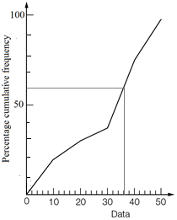

Question 7 [2.1]

A

IQR = 32 – 22 = 10

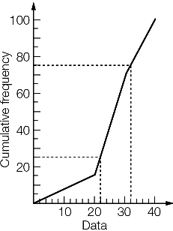

Question 8 [2.2]

B

IQR = 51 − 23 = 28 ∴ C is correct

1.5 × IQR = 42 ∴ A is correct

42 is the median ∴ D is correct

About 75% of values lie below the upper quartile, which is 51 ∴ B is incorrect

Question 9 [2.8] [10A]

**D**

Mean ≈ 4.6, standard deviation ≈ 3.07

Multiple-choice total marks: 9

Short answer section

Question 10 3 marks [2.1–2.7]

(a) Bivariate data is described using two variables.

(b) Primary data is data collected by yourself and secondary data is data collected by someone else.

Question 11 5 marks [2.1]

**(a)** To find a suitable set of numbers it is best to start with dashes to represent each value required. In this case we will try 10 dashes. Then fill in the bits known that are whole numbers.

6 ____ ____ ____ ____ ____ ____ ____ ____ 26

Now, the median is between the fifth and sixth numbers and is 12. We could use a few different number combinations here but the simplest solution is to say they are both 12.

6 ____ ____ ____ 14 14 ____ ____ ____ 26

The lower quartile is the third value so we can fill this in as 9 and the upper quartile is the eighth value and is 15.

4 ____ 10 ____ 14 14 ____ 18 ____ 26

The remaining spaces can be filled in with any values that fit numerically with the pattern.

As an example:

4 **8** 10 **12** 14 14 **16** 18 **22** 26 (The bold values could be different.)

**(b)** The following calculation is for the data set given above. (Students will not necessarily have the same values so this answer could be different.)

Mean = 

Question 12 7 marks [2.1]

|  |  |  |  |
| --- | --- | --- | --- |
| x | f | x × f | Cumulative  frequency |
| 56 | 3 | 168 | 3 |
| 57 | 2 | 114 | 5 |
| 58 | 12 | 696 | 17 |
| 59 | 20 | 1180 | 37 |
| 60 | 15 | 900 | 52 |
| Total | 52 | 3058 |  |

(a) Mean =  ( 1 d.p.)

(b)

|  |  |  |  |  |
| --- | --- | --- | --- | --- |
| Lowest | QL | Median | QU | Highest |
| 56 | 58 | 59 | 60 | 60 |

Question 13 3 marks [2.2]

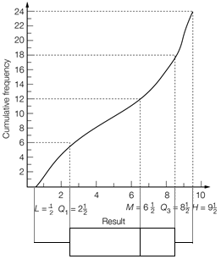

Question 14 5 marks [2.3]

(a) Set A: (i) median = 3 (ii) range = 5 − 1 = 4 (iii) IQR = 4 − 2 = 2  
Set B: (i) median = 2 (ii) range = 5 − 0 = 5 (iii) IQR = 4 − 0.5 = 3.5

(b) Set A values are higher on average. Set B data is more spread out than Set A. The lowest value is in Set B and they share the highest value.

Question 15 3 marks [2.5]

**(a)**

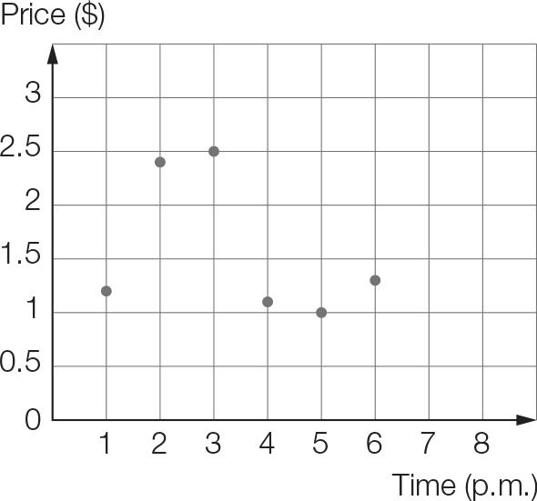

**(b)** At 1 pm the price started at $1.20 then rose significantly through to 2 pm, where the price had doubled. The price then increased over the next hour, before dropping to its initial level then increasing slightly for the final 2 hours.

Question 16 10 marks [2.2]

**(a)** Put the data in order as a first step:

1866 1866 1866 1908 1931 1934 1934 1942 1944 1944 1945 1945

1947 1950 1953 1954 1954 1955 1955 1956 1961 1963 1968 1974

lower quartile, QL: 1934 median: 1946 upper quartile, QU: 1955

IQR = 1955 − 1934 = 21 years

**(b)** QL − 1.5 × IQR = 1934 − 1.5 × 21 = 1902.5

QU + 1.5 × IQR = 1955 + 1.5 × 21 = 1986.5

So, the three 1866 values are outliers.

**(c)**

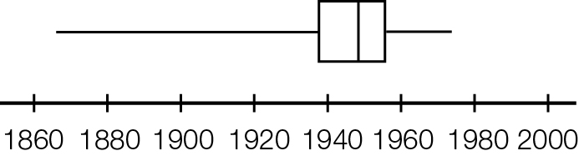

**(d)** The middle 50% occurred between 1934 and 1955.

Question 17 5 marks [2.7]

**(a)** Each group appears to be grouped according to pharmacy needs, for example a baby or small child has very different pharmaceutical needs than an older person.

**(b)** The number of items purchased for each age group can be determined by adding up the totals of each of the bars within the group.

20+ : 41 + 26 + 16 + 38 = 121

Teenagers: 7 + 18 + 4 + 23 = 52

4-12 years: 4 + 1 + 11 + 8 = 24

0-3 years: 3 + 4 + 7 = 14

The most items were purchased for the 20 and over group. The least number of items were purchased for the 0-3 year olds.

**(c)** The number of each item type can be determined by adding together the totals of the bars in each category.

Pain relief: 7 + 8 + 23 + 38 = 76

Dental Hygiene: 4 + 11 + 4 + 16 = 35

Cosmetics: 0 + 1 + 18 + 26 = 45

Prescriptions: 3 + 4 + 7 + 41 = 55

The most common item sold at Phil’s Pharmacy is pain relief followed by prescriptions, cosmetics and then dental hygiene.

**(d)** The population around Phil’s Pharmacy probably has acceptable dental hygiene, there are many factors to consider: they may purchase their toothbrushes/toothpaste/mouthwash/floss etc from another retailer i.e. the supermarket. During the time frame in which Phil collected the data, people may not have purchased as many items because they are often sold in multipacks, toothbrushes are often sold in packs of 2, 3 or 6.

**(e)** Over the time period, 45 cosmetic items were purchased, costing a total of $1733.40.  
Therefore each set has an average value of 1733.40 ÷ 45 = $38.52.

Short answer results: ___ / 41

Extended answer section

Question 18 10 marks [2.1]

|  |  |  |  |
| --- | --- | --- | --- |
| Weight (kg) | Frequency | Data  value | Cumulative  frequency |
| <64 | 0 | 64 | 0 |
| 64−<66 | 1 | 66 | 1 |
| 66−<68 | 6 | 68 | 7 |
| 68−<70 | 10 | 70 | 17 |
| 70−<72 | 17 | 72 | 34 |
| 72−<74 | 11 | 74 | 45 |
| 74−<76 | 10 | 76 | 55 |
| 76−<78 | 6 | 78 | 61 |
| 78−<80 | 5 | 80 | 66 |

(a)

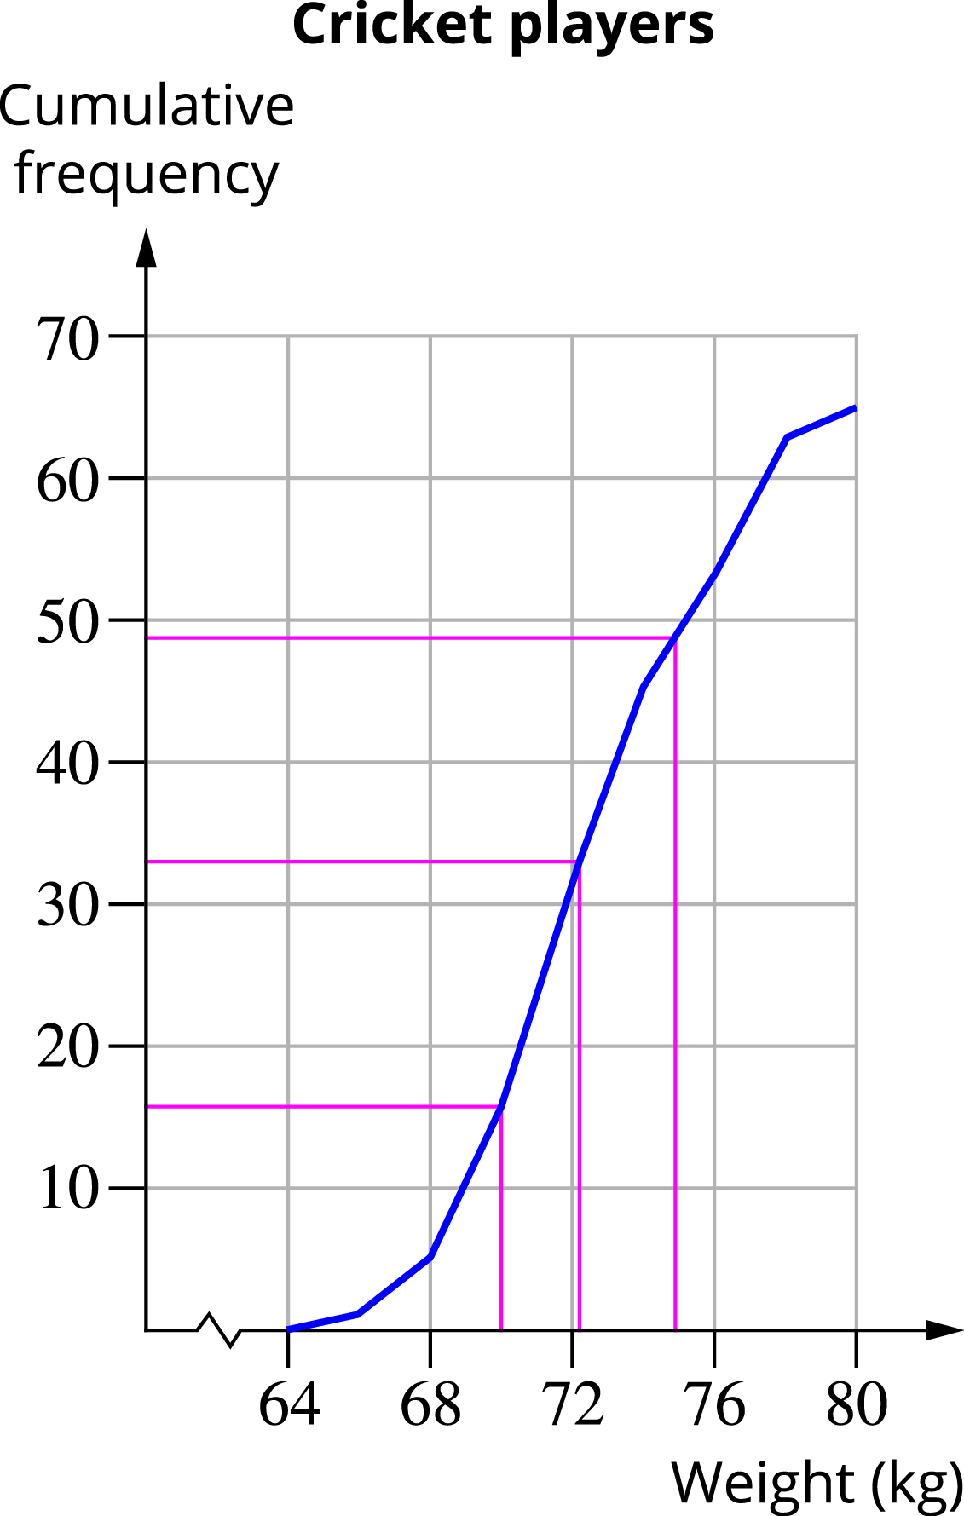

(b) As shown on the graph, the approximate values for the lower quartile is 70, the median is 72 and upper quartile is 75.

(c)

|  |  |  |  |  |
| --- | --- | --- | --- | --- |
| Min | QL | Median | QU | Max |
| 64 | 70 | 72 | 75 | 80 |

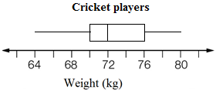

(d) The actual values could have occurred anywhere within the 2 kg class intervals for weights.  
So the minimum value of 64 kg would be in the interval 64–<66 kg.

Question 19 10 marks [2.4, 2.6] [10A]

|  |  |  |  |  |  |  |  |  |
| --- | --- | --- | --- | --- | --- | --- | --- | --- |
| English | 28 | 50 | 25 | 27 | 42 | 38 | 40 | 22 |
| Maths | 48 | 50 | 32 | 36 | 48 | 44 | 42 | 47 |

**(a) (i)** *y* = 0.32*x* + 32.41

(ii)

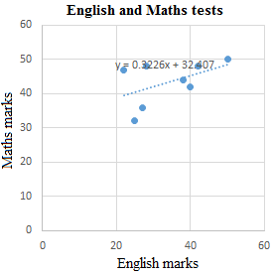

**(iii)** Maths mark = English mark × 0.32 + 32.41

**(iv)** Maths mark = 34 × 0.32 + 32.41 = 43.29  
The predicted mark for Maths is 43.

**(b) (i)** *y* = 0.77*x* + 0.62

**(ii)** English mark = Maths mark × 0.77 + 0.62

**(iii)** English mark = 38 × 0.77 + 0.62 = 29.88  
The predicted mark for English is 30.

Question 20 15 marks [2.1, 2.3]

City X: 4.5 5.1 5.1 6.4 7.1 7.8 9.1 9.3 10.8 11 12 12   
City Y: 4 5.1 5.9 8.2 9.7 12.5 14.8 17.4 17.9 20.2 20.6 21.2

**(a)** City X: min = 4.5 Q1 = 5.75 median = 8.45 Q3 = 10.9 max = 12  
City Y: min = 4 Q1 = 7.05 median = 13.65 Q3 = 19.05 max = 21.2

**(b)**

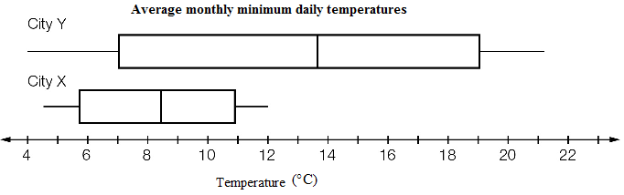

**(c)** The temperatures for City Y are, on average, higher, and more widely spread than for City X.  
City Y has the highest temperature by far, but the lowest temperatures are almost the same.

Question 21 7 marks [2.1, 2.3]

|  |  |  |  |  |  |  |  |  |  |  |  |  |  |  |  |  |  |  |  |  |  |  |  |  |  |  |  |  |  |  |  |  |  |  |  |  |  |
| --- | --- | --- | --- | --- | --- | --- | --- | --- | --- | --- | --- | --- | --- | --- | --- | --- | --- | --- | --- | --- | --- | --- | --- | --- | --- | --- | --- | --- | --- | --- | --- | --- | --- | --- | --- | --- | --- |
| (a)   |  |  |  | | --- | --- | --- | | x | f | x × f | | 1 | 3 | 3 | | 2 | 3 | 6 | | 3 | 6 | 18 | | 4 | 2 | 8 | | 5 | 4 | 20 | | 6 | 2 | 12 | | 7 | 3 | 21 | | 8 | 0 | 0 | | 9 | 1 | 9 | | 10 | 1 | 10 | | Total | 25 | 107 |   Mean =  ≈ 4.3  On average 4.3 games won by the winning teams. | **(b)** ‘More than half’ is 6-10 games. Number of teams = 2 + 3 + 0 + 1 + 1 = 7 teams  Portion =  = 0.28  28% of winning teams won more than half of their games. |
| (c)   |  |  |  | | --- | --- | --- | | x | f | x × f | | 0 | 5 | 0 | | 1 | 3 | 3 | | 2 | 3 | 6 | | 3 | 6 | 18 | | 4 | 2 | 8 | | 5 | 4 | 20 | | 6 | 2 | 12 | | 7 | 3 | 21 | | 8 | 0 | 0 | | 9 | 1 | 9 | | 10 | 1 | 10 | | Total | 30 | 107 |   Mean =  ≈ 3.6  On average 3.6 games won by all teams. | **(d)** Portion =  ≈ 0.23  About 23% of all teams won more than half of their games. |

Question 22 18 marks [2.3, 2.8]

(a)

|  |  |
| --- | --- |
| Weight (kg) | Frequency |
| 50–<55 | 12 |
| 55–<60 | 7 |
| 60–<65 | 7 |
| 65–<70 | 8 |
| 70–<75 | 6 |

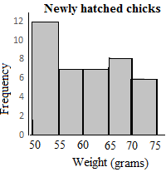

(b) The data in order:

52 52 52 53 53 53 53 54 54 54 | 54 54 55 55 56 57 57 57 58 60

60 61 63 63 63 64 65 65 65 65 | 66 67 67 67 70 71 72 73 73 74

|  |  |  |  |  |
| --- | --- | --- | --- | --- |
| Min | QL | Median | QU | Max |
| 52 | 54 | 60 | 65.5 | 74 |

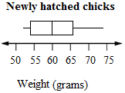

(c)

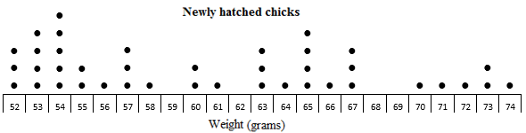

**(d)** The dot plot has the raw data so you can see exactly how many of each weight. The weights range from 52 g to 74 g with five chicks at 54 g. The histogram shows a fairly uniform distribution apart from a peak at the lowest weight range. Weights are from 50 g to 75 g. The box plot shows the weights from 52 g to 74 g with amounts more spread out for the higher weights.

[10A] **(e)** From a calculator: Mean ≈ 60.7 g, SD ≈ 6.84 g

[10A](f) (These are sample answers; students will almost certainly get different values.)

24 29 20 16 17 → 54, 65, 64, 57, 66  
22 8 5 33 28 → 57, 57, 74, 55, 67  
20 19 6 3 8 → 64, 56, 65, 52, 57  
15 24 7 6 28 → 70, 54, 53, 65, 67  
16 28 34 17 3 → 57, 55, 52, 66, 52  
39 24 12 27 28 → 63, 54, 54, 73, 67

Sample 1: 54, 65, 64, 57, 66  
Sample 2: 57, 57, 74, 55, 67  
Sample 3: 64, 56, 65, 52, 57  
Sample 4: 70, 54, 53, 65, 67  
Sample 5: 57, 55, 52, 66, 52  
Sample 6: 63, 54, 54, 73, 67

[10A] **(g)** From a calculator, using sample standard deviations:

Sample 1: mean = 61.2, SD = 5.36  
Sample 2: mean = 62, SD = 8.19  
Sample 3: mean = 58.8, SD = 5.54  
Sample 4: mean = 61.8, SD = 7.79  
Sample 5: mean = 56.4, SD = 5.77  
Sample 6: mean = 62.2, SD = 8.29

[10A] (h)  
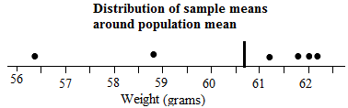

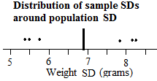

Extended answer results: ___ / 60

TOTAL test results: ___ / 110